CrowdTSocialTDistanceTAndTMaskTDetectionTusingTClassicalTMachineTLearningT

*SagarTChandraTKalauni*

*DepartmentTofTComputerTScienceTandTEngineering,TGraphicTEraTHillTUniversity,TDehradun*

*Sagarchandra5730@gmail.com*

***Abstract*—TAsTtheTCOVID-19TpandemicTcontinuesTtoTposeTaTthreatTtoTpublicThealthTandTsafety,TthereTisTanTurgentTneedTforTinnovativeTsolutionsTtoTmitigateTtheTspreadTofTtheTvirus.TInTthisTpaper,TweTpresentTaTcomputerTvision-basedTsystemTforTdetectingTsocialTdistancingTviolationsTandTmask-wearingTcomplianceTinTcrowdedTpublicTspaces.TTheTsystemTusesTaTcombinationTofTdeepTlearningTalgorithmsTandTimageTprocessingTtechniquesTtoTanalyseTcameraTfeedsTandTidentifyTviolationsTinTreal-time.T**

**WeTdescribeTtheTarchitectureTofTtheTsystem,TwhichTincludesTaTcameraTnetwork,TedgeTdevicesTforTimageTprocessingTandTanalysis,TandTaTcentralTserverTforTdataTmanagementTandTreporting.TWeTalsoTevaluateTtheTaccuracyTandTefficiencyTofTtheTsystemTusingTaTdatasetTofTsimulatedTcrowdTscenariosTandTreal-worldTtestsTinTpublicTspaces.T**

**T**

***Keywords—TCOVID-19,TMaskedTface,TDeepTlearning,T***

***ClassicalTmachineTlearning***T

T

# INTRODUCTIONT

T

TheTemergenceTandTrapidTglobalTspreadTofTaTnewTstrainTofTcoronavirusTknownTasTSARS-CoV-2ToriginatedTinTWuhan,TChina,TandTwasTofficiallyTdeclaredTaTworldwideTpandemicTbyTtheTWorldTHealthTOrganizationT(WHO).TThisTledTtoTtheTdevelopmentTofTtheTcoronavirusTdiseaseT(COVID-19).TSinceTitsTonset,TCOVID-19ThasTbeenTresponsibleTforTaTstaggeringTnumberTofTcases,TwithTaTrecordedTtotalTofT220,563,227TpositiveTcasesTandT4,565,483TdeathsTworldwide.TWhileTtheTintroductionTofTvaccinesTinitiallyTbroughtTsomeTreassuranceTtoTpopulationsTworldwide,TreportsTofTCOVID-19TinfectionsTamongTvaccinatedTindividualsTraisedTconcernsTandThighlightedTtheTimportanceTofTadheringTtoTrecommendedTmeasures,TsuchTasTfollowingTWHO'sTstandardToperatingTproceduresT(SOPs)TwhichTincludeTwearingTfaceTmasksTandTpractisingTsocialTdistancing.TItTisTworthTnotingTthatTpriorTtoTthisToutbreak,TfaceTmasksTwereTcommonlyTusedTasTaTpreventiveTmeasureTagainstTairTpollution,TasTparamedicalTworkersTinThospitalsTorTtoTconcealTtheirTidentitiesTwhenTcommittingTcrimes,Tetc.THowever,TduringTtheTpandemic,TeveryoneTmustTwearTaTfaceTmaskTinTpublicTplacesTtoTstopTCOVID-19TfromTspreading.TAlthoughTCOVID-19TcasesThaveTcomeTdownTnowTasTofT2023TandTpeopleTdoTnotThaveTmuchTconcernTregardingTit,TitTcanTstillTspreadTifTprecautionsTareTnotTtaken.TControllingTCOVID-19TdistributionTisTcurrentlyTaTmajorTconcernTforTWHOTpolicymakersTandTallTofThumanity.TWearingTaTfaceTmaskTlowersTtheTspreadTofTCOVID-19TbyTloweringTtheTlikelihoodTofTrespiratoryT(virus-laden)TdropletsTbeingTtransmitted,TaccordingTtoTmostTofTtheTevidenceTfromTtheTWHO,TanalysisTandTstudy.TConsequently,TnumerousTcountriesThaveTimplementedTmandatoryTfaceTmaskTrequirementsTinTpublicTsettingsTasTaTpreventiveTmeasureTtoThaltTtheTtransmissionTofTCOVID19.ItTisTchallengingTtoTmanuallyTcheckTpeopleTinTpublicTplacesTforTfaceTmasks.TTherefore,TitTisTnecessaryTtoTdevelopTautomatedTtechniquesTforTspottingTfaceTmasks.TToTpreventTtheTCOVID-19TvirusTfromTspreadingTquicklyTthroughoutTaTcommunity,TgovernmentsTmustTrequireTpeopleTtoTwearTfaceTmasks.THowever,TwearingTaTfaceTmaskTalsoTposesTadditionalTproblemsTforTfaceTrecognitionTsoftwareTthatTisTgenerallyTmadeTforTfacesTthatTareTnotTcoveredTup.TTheseTfacialTrecognitionTprograms,TwhichThaveTbeenTimplementedTatTseveralTcheckpoints,TfunctionTlessTwellTwhenTmaskedTfacesTareTpresentTbecauseTimportantTfacialTfeaturesTlikeTtheTnose,Tlips,Tchin,Tcheeks,TandTsoTonTareTlost.T

TheTchallengesTposedTbyTfaceTmasksThaveTresultedTinTsignificantTobstaclesTforTfacialTrecognitionTtechnologies,TparticularlyTinTapplicationsTthatTrequireTverificationTorTauthentication.TThisTincludesTmobileTpayments,TpublicTsafetyTinspections,TphoneTunlocking,TattendanceTtracking,TandTmore.TForTexample,TaccessTgatesTatTsecurityTcheckpointsTinTpublicTtransportationThubs,TsuchTasTtrainTandTbusTterminals,TcommonlyTemployTcamerasTandTrelyTonTconventionalTfaceTrecognitionTmethods,TwhichTproveTineffectiveTwhenTindividualsTareTwearingTfaceTmasks.TAdditionally,TtheTuseTofTtraditionalTbiometric-basedTtechniquesTlikeTfingerprintTandTfacialTrecognitionThasTbeenTdiscouragedTduringTtheTCOVID-19TpandemicTdueTtoTtheTpotentialTtransmissionTofTtheTvirusTamongTusers.T

InTaddressingTthisTpandemic,TautomatedTuserTverificationTsystemsTthatTareTcapableTofTidentifyingTindividualsTwearingTfaceTmasksThaveTemergedTasTaTpotentialTsolution.THowever,TtheTexistingTfacialTrecognitionTtechnologiesTfaceTchallengesTinTaccuratelyTrecognizingTmaskedTfaces,TmakingTthemTlessTreliableTinTthisTcontext.TWhileTsomeTstudiesTonTmaskedTfaceTrecognitionThaveTbeenTconductedTrecently,TthisTresearchTproblemTremainsTlargelyTunexploredTandTlacksTcomprehensiveTinvestigation.TTheTlimitedTavailabilityTofTresourcesTinTthisTparticularTfieldTcouldTbeTaTcontributingTfactorTtoTtheTscarcityTofTresearchTinTthisTarea.T

TIndeed,TwhileTthereTareTnumerousTlarge-scaleTandTdiverseTfacialTrecognitionTdatasetsTavailableTthatTfocusTonTunmaskedTfaces,TtheTexistenceTofTwidelyTusedTdatasetsTspecificallyTtailoredTforTmaskedTfaceTrecognitionTisTlimited.TToTtheTbestTofTourTknowledge,TthereTisTcurrentlyTaTlackTofTextensivelyTutilisedTdatasetsTthatTspecificallyTcaterTtoTtheTuniqueTchallengesTandTcharacteristicsTassociatedTwithTmaskedTfaceTrecognition.TThisTabsenceTofTcomprehensiveTdatasetsThampersTtheTprogressTandTdevelopmentTofTeffectiveTmaskedTfaceTrecognitionTsystems.T

TheTrestTofTtheTreportTisTstructuredTinTtheTfollowingTmanner.TSectionT2TdescribesTtheTassociatedTwork.TInTSectionT3,TweTdescribedTtheTproposedTeffortTandTexplainedTitsTjustification.TTheTspecificsTofTourTinternalTdatasetTandTtheToutcomesTofTtheTexperimentsTwereTcoveredTinTSectionT4.TSectionT5TbringsTourTdiscussionTtoTaTclose.T

T

# RELATEDTWORKT

InTgeneral,TfaceTconstructionTandTidentityTrecognitionTwhileTwearingTfaceTmasksTareTtheTmainTtopicsTofTpublications.TInTorderTtoTreduceTtheTtransmissionTandTspreadTofTtheTCOVID-19,TourTresearchTfocusesTonTidentifyingTthoseTwhoTareTnotTdonningTfaceTmasks.TResearchersTandTscientistsThaveTestablishedTthatTusingTaTfaceTmaskTreducesTtheTrateTatTwhichTCOVID-19Tspreads.TTheTauthorsTofT[6]TcreatedTaTbrand-newTfacemask-wearingTconditionTidentificationTtechnique.TTheyTwereTableTtoTdivideTtheTuseTofTfacemasksTintoTthreeTgroups.TCorrectTfacemaskTuse,TwrongTfacemaskTuse,TandTnoTfacemaskTuseTareTtheTthreeTcategories.TTheTsuggestedTalgorithm'sTfaceTdetectionTphaseTaccuracyTwasT98.70%.TInTorderTtoTidentifyTtheTperson,TSabbirTetTal.T[7]TusedTtheTPrincipalTComponentTAnalysisT(PCA)TonTbothTmaskedTandTunmaskedTfacialTrecognition.TTheyTdiscoveredTthatTwearingTmasksThadTaTsignificantTimpactTonTtheTaccuracyTofTfaceTresonanceTusingTtheTPCA.TWhenTtheTrecognisedTfaceTisThidden,TtheTrecognitionTaccuracyTfallsTtoTunderT70%.TPCATwasTalsoTusedTinT[8].TTheTauthorsTsuggestedTaTtechniqueTforTtakingToffTspectaclesTfromTaTperson'sTfrontalTfaceTappearance.TRecursiveTerrorTcorrectionTwithTPCATreconstructionTwasTusedTtoTreconstructTtheTremovedTportion.T

ForTfaceTdetectionTinT[9],TtheTauthorsTemployedTtheTYOLOv3Talgorithm.TYOLOv3'sTDarknet-53TservesTasTitsTfoundation.TTheTaccuracyTofTtheTsuggestedTmethodTwasT93.9%.TMoreTthanT600,000TphotosTfromTtheTWIDERTFACETandTCelebATdatasetsTwereTusedTforTtraining.TTheTFDDBTdatasetTwasTtested.TATuniqueTGAN-basedTnetworkTwasTsuggestedTbyTNizamTetTal.T[10]TthatTcanTautomaticallyTremoveTmasksTcoveringTtheTfacialTareaTandTrecreateTtheTimageTbyTfillingTinTtheTemptyTspace.TTheTsuggestedTmodelTproducesTaTcompleteTfaceTimageTthatTappearsTrealisticTandTnatural.T

TheTauthorsTofT[11]TpresentedTaTsystemTforTdeterminingTwhetherTorTnotTaTrequiredTmedicalTmaskTisTpresentTinTtheToperatingTroom.TTheTgeneralTgoalTisTtoTreduceTtheTnumberTofTfalseTpositiveTfaceTdetectionsTwhileTmaintainingTtheTabilityTtoTrecogniseTmasks,TinTorderTtoTonlyTraiseTwarningsTforTmedicalTpersonnelTwhoTdoTnotTwearTsurgicalTmasks.TTheTsuggestedTsystemTarchivedTdataTwithT95%Taccuracy.T

TheTdeploymentTofTmaskTdetectionTandTmaskedTfacialTrecognitionTsystemsTfacesTseveralToperationalTchallengesTinTtheTcontextTofTtheTCOVID-19Tera.TAsTaTresult,TaTfewTrecentTresearchTprojectsThaveTspecificallyTfocusedTonTaddressingTtheseTissuesTinTtheTareasTofTfaceTmaskTdetectionTandTmaskedTfacialTrecognitionT

ExistingTresearchTonTfaceTmaskTdetectionTcanTbeTcategorisedTintoTthreeTgroups:ThybridTapproaches,TdeepTlearningT(DL)TbasedTmethods,TandTtraditionalTmachineTlearningT(ML)Tmethods.THybridTapproachesTcombineTbothTdeepTlearningTandTtraditionalTmachineTlearningTtechniques.TTheTworksTbyTGengTetTal.T(2020),TUdTDinTetTal.T(2020),TLiTetTal.T(2020),TVenkateswarluTetTal.T(2020),TandTQinTandTLiT(2020)TareTexamplesTofTstudiesTinTthisTfield.T

ThisTsectionTprovidesTanToverviewTofTrelevantTstudiesTonThumanTdetectionTusingTdeepTlearning.TItTalsoTdiscussesTtheTmajorityTofTrecentTworksTinTobjectTclassificationTandTdetectionTthatTemployTdeepTlearningTtechniques.TTheTreviewTprimarilyTfocusesTonTcurrentTresearchTinTmachineTlearning-basedTobjectTdetection.TInTcomputerTvision,ThumanTdetectionTisTconsideredTaTtaskTofTidentifyingTandTlocalisingThumanTshapesTinTvideoTimagery,TakinTtoTobjectTdetection.TDeepTlearningThasTemergedTasTaTprominentTapproachTforTmulti-classTobjectTrecognitionTandTdetectionTinTartificialTintelligence,TdeliveringTimpressiveTresultsTonTchallengingTdatasets.TNguyenTetTal.TconductedTanTextensiveTanalysisTofTtheTstate-of-the-artTinThumanTdetection,TencompassingTrecentTdevelopmentsTandTchallenges.TTheirTsurveyTprimarilyTexaminesThumanTdescriptors,TmachineTlearningTalgorithms,TocclusionThandling,TandTreal-timeTdetection.TDeepTconvolutionalTneuralTnetworksT(CNNs)ThaveTdemonstratedTexceptionalTperformanceTinTvisualTrecognitionTandThaveTsurpassedTvariousTimageTrecognitionTbenchmarks.T

BuildingTuponTtheTconceptTintroducedTinTreferenceT[12],TweTproposeTaTcomputerTvisionTapproachTtoTdetectTindividualsTusingTaTcameraTpositionedTeitherTatTtheTroadsideTorTinTaTworkspace.TTheTcamera'sTfieldTofTviewTcapturesTpeopleTmovingTwithinTaTdesignatedTarea.TUtilisingTestablishedTdeepTConvolutionalTNeuralTNetworkT(CNN)Ttechniques,TsuchTasTtheTYOLOTmethod,TweTcanTdetectTtheTnumberTofTindividualsTpresentTinTimagesTandTvideos,TandTgenerateTboundingTboxesTaroundTthem.TByTcalculatingTtheTEuclideanTdistanceTbetweenTpeople,TourTapplicationTcanTdetermineTifTthereTisTanTadequateTsocialTdistanceTmaintainedTbetweenTindividualsTinTtheTvideo,TtherebyTprovidingTvisualTindicators.T

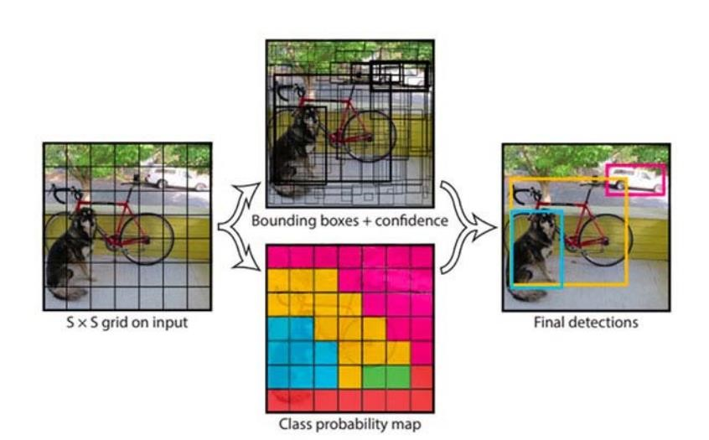

FigureT1:YoloTClassificationTpreviewT

# METHODOLOGYT

*3.1TMASKTDETECTIONT*

1. *DataTCollectionT*

TheTfirstTstepTinTtheTmethodologyTwasTtoTcollectTrelevantTdataTforTtheTproject.TWeTcollectedTaTdiverseTdatasetTconsistingTofTimagesTofTpeopleTfromTvariousTsources,TincludingTpublicTdomains,TsurveillanceTcameras,TandTsocialTmediaTplatforms.TTheTdatasetTcontainsTmaskedTandTwithoutTmaskTimagesTofTpeople,TTheTdatasetTwasTcuratedTtoTincludeTpeopleTofTdifferentTageTgroups,Tgenders,TandTethnicities.T

T

1. *DataTPreprocessingT*

TheTcollectedTdatasetTwasTpreprocessedTtoTenhanceTitsTqualityTandTmakeTitTsuitableTforTtrainingTtheTdeepTlearningTmodel.TWeTperformedTimageTresizing,Tnormalisation,TandTaugmentationTtoTensureTuniformityTinTtheTdata.TTheTimagesTwereTalsoTlabelledTbasedTonTtheTpresenceTorTabsenceTofTmasksTandTtheTdistanceTbetweenTpeopleTinTtheTframe.T

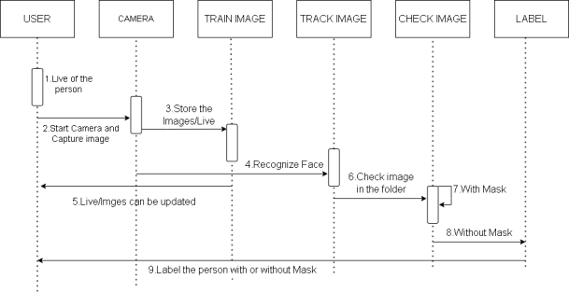

FigureT2:TimingTDigramT

T

1. *ModelTTrainingT*

WeTusedTtheTConvolutionalTNeuralTNetworkT(CNN)TarchitectureTforTbuildingTtheTdeepTlearningTmodel.TTheTmodelTwasTtrainedTonTtheTpreprocessedTdatasetTusingTaTGPUTtoTaccelerateTtheTtrainingTprocess.TTheTtrainingTwasTconductedTinTtwoTphases:TtheTfirstTphaseTinvolvedTtrainingTtheTmaskTdetectionTmodel,TandTtheTsecondTphaseTinvolvedTtrainingTtheTsocialTdistancingTmodel.T

T

1. *EvaluationTofTModelT*

ToTevaluateTtheTperformanceTandTaccuracyTofTtheTtrainedTmodel,TaTseparateTtestTdatasetTwasTused.TTheTtestTdatasetTcomprisedTimagesTandTvideosTofTindividualsTcollectedTfromTdiverseTsources,TsuchTasTpublicTdomains,TsurveillanceTcameras,TandTsocialTmediaTplatforms.TVariousTmetrics,TincludingTaccuracy,Tprecision,Trecall,TandTF1Tscore,TwereTemployedTtoTconductTtheTevaluationTandTassessTtheTmodel'sTeffectivenessTinTfaceTmaskTdetection.T

T

1. *ModelTDeploymentT*

Finally,TtheTtrainedTandTevaluatedTmodelTwasTdeployedTonTaTreal-timeTsystemTtoTdetectTsocialTdistancingTviolationsTandTmaskTnon-compliance.TTheTmodelTwasTintegratedTwithTaTcamera-basedTsystemTtoTprovideTreal-timeTalertsTtoTtheTauthoritiesTinTcaseTofTanyTviolations.TTheTsystemTwasTtestedTinTvariousTscenariosTtoTensureTitsTeffectivenessTandTaccuracy.T

*3.2TCROWDTSOCIALTDISTANCINGT*

ThisTtoolTwasTdevelopedTtoTidentifyTtheTappropriateTdistanceTbetweenTindividualsTinTpublicTareasTbyTutilisingTtechniquesTsuchTasTdeepTCNNTandTcomputerTvision.TInitially,TanTopen-sourceTobjectTdetectionTnetworkTbasedTonTtheTYOLOv3TalgorithmTwasTutilisedTtoTdetectTpedestriansTinTvideoTframes.TOnlyTtheTpedestrianTclassTwasTconsidered,TwhileTotherTobjectTclassesTwereTdisregarded.TAsTaTresult,TboundingTboxesTwereTdrawnTaroundTeachTdetectedTpedestrian,TandTthisTdataTwasTusedTforTdistanceTmeasurement.T

T

ForTtheTcameraTsetup,TaTfixed-angleTcameraTcapturedTtheTvideoTframes,TwhichTwereTthenTtransformedTfromTaTperspectiveTviewTtoTaTtwo-dimensionalTtop-downTviewTtoTenhanceTtheTaccuracyTofTdistanceTestimation.TTheTmethodologyTassumesTthatTpedestriansTinTtheTvideoTframesTareTwalkingTonTtheTsameTflatTplane.TFourTpointsTonTtheTfilmedTplaneTwereTselectedTandTtransformedTintoTtheTtopdownTviewTtoTestimateTtheTlocationTofTeachTpedestrian.TTheTdistanceTbetweenTpedestriansTwasTmeasuredTandTscaledTaccordingly.TIfTtheTdistanceTbetweenTanyTtwoTindividualsTfellTbelowTtheTpredeterminedTminimumTdistance,TredTlinesTwereTdisplayedTasTprecautionaryTwarnings.TTheTimplementationTofTthisTtoolTwasTcarriedToutTusingTtheTPythonTprogrammingTlanguage.T

T



T



T



T



T



T



InputTtheTvideoTframe

T



CrowdTDetection

T



CalibrationTofTcameraTviewT

T



DistanceTmeasurement

T



OutputTresult

T

FigureT3:FlowchartT1T

1. *DataTCollectionTandTPreprocessingT*

TheTvideoTdataTusedTinTthisTresearchTwasTcollectedTfromTtheTspecifiedTsource.TTheTvideoTframesTwereTreadTusingTOpenCV'sTVideoCaptureTfunction,TandTeachTframeTwasTresizedTtoTaTwidthTofT700TpixelsTtoTfacilitateTprocessing.T

T

1. *PersonTDetectionT*

ATpre-trainedTYOLOT(YouTOnlyTLookTOnce)TobjectTdetectionTmodelTwasTutilisedTtoTdetectTpeopleTwithinTtheTvideoTframes.TTheTYOLOTmodelTwasTimplementedTusingTOpenCVTandTloadedTwithTpre-trainedTweightsTtrainedTonTtheTCOCOT(CommonTObjectsTinTContext)Tdataset.TTheTYOLOTmodelTwasTconfiguredTwithTaTconfidenceTthresholdTofT0.3TtoTfilterTweakTdetections.TTheTframesTwereTprocessedTthroughTtheTYOLOTmodel,TwhichTgeneratedTboundingTboxTcoordinatesTandTassociatedTconfidencesTforTeachTdetectedTobject.TOnlyTobjectsTclassifiedTasT"person"TandTsurpassingTtheTminimumTconfidenceTthresholdTwereTconsideredTasTvalidTdetections.T

T

1. *SocialTDistanceTComputationT*

ToTdetermineTsocialTdistancingTviolations,TtheTcentroidsTofTtheTdetectedTpeopleTwereTextractedTfromTtheTYOLOTresults.TEuclideanTdistancesTwereTcomputedTbetweenTallTpairsTofTcentroidsTusingTtheTSciPyTlibrary.TIfTtheTdistanceTbetweenTanyTtwoTcentroidTpairsTwasTfoundTtoTbeTlessTthanTtheTconfiguredTminimumTsafeTdistanceT(100Tpixels),TtheTcentroidTpairTwasTconsideredTaTviolation.T

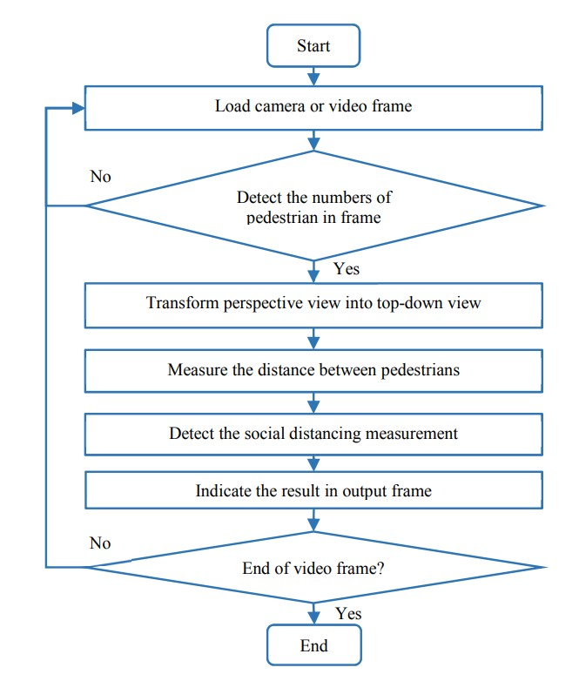

FigureT4:FlowchartT2T

1. *VisualizationTandTOutputT*

TheTviolationsTwereTvisualisedTbyTdrawingTboundingTboxesTaroundTtheTdetectedTpeopleTandTannotatingTtheirTcentroidTcoordinatesTonTtheTvideoTframes.TViolationsTwereThighlightedTwithTaTredTcolour,TwhileTnon-violatingTpeopleTwereTmarkedTwithTaTgreenTcolour.TTheTtotalTnumberTofTsocialTdistancingTviolationsTwasTdisplayedTonTeachTframe.TAdditionally,TtheTprocessedTframesTcouldTbeTdisplayedTinTreal-timeTorTsavedTtoTanToutputTvideoTfile,TdependingTonTtheTuser'sTchoice.T

T

1. *ParameterTConfigurationT*

VariousTparameters,TsuchTasTtheTminimumTconfidenceTthresholdTforTpersonTdetectionT(MIN_CONF),TtheTnonmaximaTsuppressionTthresholdT(NMS_THRESH),TandTtheTminimumTsafeTdistanceT(MIN_DISTANCE),TwereTsetTbasedTonTexperimentationTandTdomainTknowledge.TTheseTparametersTwereTcarefullyTselectedTtoTbalanceTdetectionTaccuracyTandTcomputationalTefficiency.T

**T**

# RESULTSTANDTDISCUSSIONT

InTthisTstudy,TweTtrainedTaTclassicalTmachineTlearningTmodelTtoTdetectTsocialTdistanceTviolationsTandTmaskTwearingTinTcrowds.TWeTusedTaTdatasetTofT1376TimagesTofTpeopleTwithTandTwithoutTmasks.TWeTtrainedTtheTcrowdTsocialTdistancingTmodelTonTPascalTVOCTdatasetT2012.T

TheTmodelTwasTtrainedTusingTdeepTlearningTwithThyperparametersTtunedTusingTgridTsearch.TWeTevaluatedTtheTperformanceTofTtheTmodelTusingTaccuracy,Tprecision,Trecall,TF1-score,TconfusionTmatrix,TandTclassificationTreport.T

T

*6.1***T***DatasetTCharacteristicsT*

TheTdatasetTusedTforTevaluationTofTfaceTmasksTconsistsTofTtwoTdistinctTsetsTofTimages.TTheTfirstTsetTcontainsTphotosTofTindividualsTwearingTmasks,TwhileTtheTsecondTsetTcomprisesTphotosTofTindividualsTwithoutTmasks.T

1. WithTmask:TThereTareTaTtotalTofT690TimagesTunderTtheTwithTmaskTfolder.T

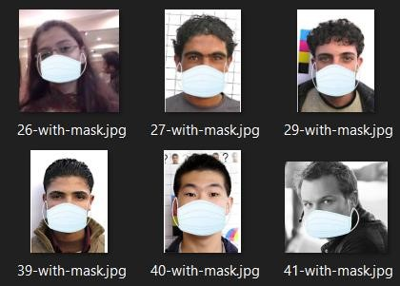

FigureT5:FaceTmaskTdatasetTwithTmaskT

1. WithoutTmask:TThereTareTaTtotalTofT686TimagesTunderTtheTwithTmaskTfolderT

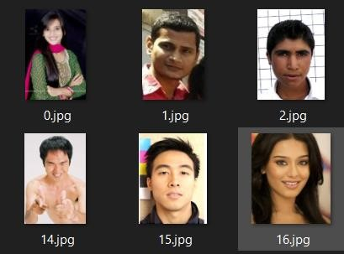

FigureT6:FaceTmaskTdatasetTwithoutTmaskT

80%TofTtheTimagesTareTusedTforTtrainingTtheTmodelTandT20%TisTusedTforTtesting.T

TheTdatasetTusedTforTtheTcrowdTsocialTdistancingTmodelTisTPascalTVOCTdatasetT2012.TThisTdatasetTisTwidelyTrecognizedTasTtheTstandardTforTtasksTsuchTasTImageTSegmentation,TObjectTDetection,TLocalization,TandTmore.T

InTimageTsegmentation,TtheTobjectiveTisTtoTpredictTtheTlabelTforTeachTindividualTpixelTinTanTimage.T

ForTobjectTdetection,TtheTgoalTisTtoTidentifyTandTspecifyTtheTclassesTpresentTinTaTgivenTimage.TAdditionally,TboundingTboxesTcanTbeTusedTtoTencompassTandTdefineTtheTlocationTofTeachTobjectTwithinTtheTimage.T

ThereTareTtwoTfolders,ToneTforTtheTvalidationTandTtrainingTsets,TandTanotherTforTtheTtestTset.TWithinTtheT"train_val"Tdirectory,TthereTisTanT"Image"TfolderTthatTcontainsTaTtextTfileTrepresentingTtheTtrainingTandTvalidationTinstances.TEachTimageTinTtheTfolderThasTclassTlabelsTandTobjectTlabelsTalongTwithTannotations.TTheTlabelledTimagesThaveTclassTlabelsTassignedTtoTeachTpixel.T

TheTtestTsetTfollowsTaTsimilarTstructure.TTheTpredictedTlabelsTforTtheTtestTsetTcanTbeTfoundTinTeitherTtheT"SegmentationClass"TorT"SegmentationObject"Tfolder,TdependingTonTtheTspecificTapplicationTyouTareTworkingTon.T

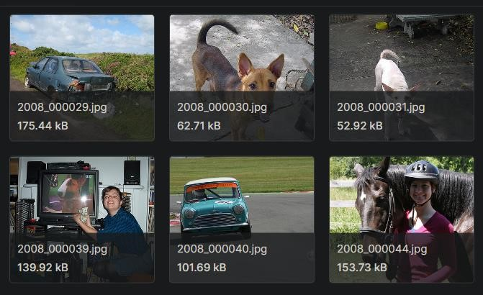

FigureT7:ObjectTdetectionTdatasetT

\

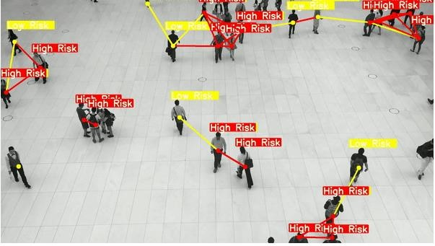

FigureT8:ObjectTdetectionTOutputT1T

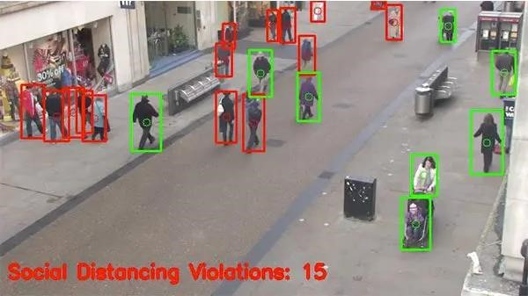

FigureT9:ObjectTdetectionTOutputT2T

RealTtimeTOutput:T

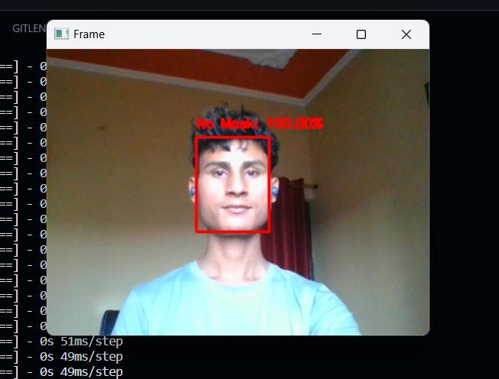

FigureT8:MaskTdetectionTOutputT1T

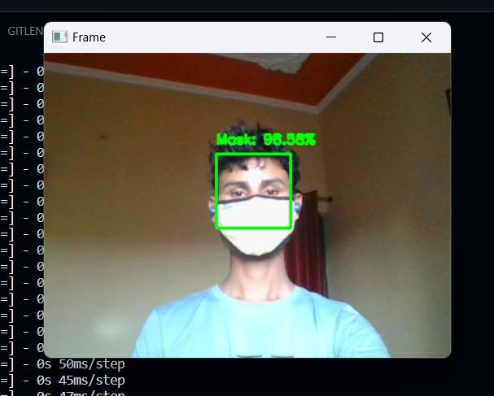

FigureT9:FaceTmaskTdetectionTOutputT2T

TheTresultsTshowedTthatTourTmodelTachievedTanTaccuracyTofT0.99,TrecallTofT0.1,TandTF1-scoreTofT0.99TforTdetectingTmaskTwearing.T

OurTstudyTcontributesTtoTtheTgrowingTliteratureTonTmachineTlearning-basedTapproachesTtoTaddressTtheTchallengesTposedTbyTtheTCOVID-19Tpandemic.THowever,TourTstudyThasTseveralTlimitations,TincludingTtheTrelianceTonTaTsingleTdatasetTandTtheTneedTforTfurtherTvalidationTinTreal-worldTsettings.TFutureTresearchTcouldTexploreTtheTuseTofTdeepTlearningTapproachesTandTtheTintegrationTofTreal-timeTvideoTanalysisTtoTimproveTtheTaccuracyTandTusabilityTofTtheTmodel.T

InTconclusion,TourTstudyTdemonstratesTtheTpotentialTofTclassicalTmachineTlearningTmodelsTtoTdetectTsocialTdistanceTviolationsTandTmaskTwearingTinTcrowds,TwhichTcouldThaveTimportantTimplicationsTforTpublicThealthTandTsafety.T

T

# CONCLUSIONTANDTFUTURETWORKST

CrowdTsocialTdistancingTandTmaskTdetectionTtechnologiesThaveTemergedTasTpromisingTtoolsTforTpromotingTpublicThealthTandTsafetyTduringTtheTCOVID-19Tpandemic.TByTleveragingTcomputerTvisionTandTmachineTlearningTalgorithms,TtheseTsystemsTcanTautomaticallyTdetectTindividualsTwhoTareTnotTwearingTmasksTorTstandingTtooTcloseTtoToneTanother,TalertingTauthorities,TandTremindingTpeopleTtoTcomplyTwithTsocialTdistancingTguidelines.TWhileTtheseTtechnologiesThaveTtheirTlimitations,TsuchTasTtheTriskTofTfalseTpositivesTandTtheTpotentialTforTprivacyTviolations,TtheyTrepresentTanTimportantTstepTforwardTinTourTcollectiveTeffortsTtoTcombatTtheTspreadTofTinfectiousTdiseases.TAsTtheTpandemicTcontinuesTtoTevolveTandTnewTchallengesTemerge,TitTisTlikelyTthatTcrowdTsocialTdistancingTandTmaskTdetectionTtechnologiesTwillTplayTanTincreasinglyTimportantTroleTinTensuringTpublicThealthTandTsafety.T

InTconclusion,TourT"crowdTsocialTdistancingTandTmaskTdetection"TprojectTaimedTtoTaddressTtheTchallengesTofTmaintainingTpublicThealthTandTsafetyTduringTtheTCOVID19Tpandemic.TByTdevelopingTaTcomputerTvision-basedTsystemTthatTcanTdetectTsocialTdistancingTviolationsTandTmask-wearingTcompliance,TweThaveTdemonstratedTtheTpotentialTofTtechnologyTtoTassistTinTmitigatingTtheTspreadTofTtheTvirusTinTpublicTspaces.T

OurTprojectThasTseveralTbenefits,TincludingTtheTabilityTtoTmonitorTlargeTcrowdsTinTreal-time,TincreaseTawarenessTandTadherenceTtoTpublicThealthTguidelines,TandTalertTauthoritiesTinTcaseTofTanyTviolations.TWithTfurtherTimprovementsTandTdeployment,TthisTsystemThasTtheTpotentialTtoTbecomeTanTimportantTtoolTinTtheTfightTagainstTCOVID-19TandTotherTinfectiousTdiseases.T

Overall,TweTbelieveTthatTourT"crowdTsocialTdistancingTandTmaskTdetection"TprojectThasTdemonstratedTtheTpotentialTofTcomputerTvisionTandTAITtoTcontributeTtoTpublicThealthTandTsafetyTinTaTmeaningfulTway.TWeThopeTthatTourTworkTwillTinspireTfurtherTresearchTandTdevelopmentTinTthisTareaTandTcontributeTtoTtheTongoingTeffortsTtoTcontrolTtheTspreadTofTCOVID-19TandTotherTinfectiousTdiseases.T

TheTfutureTworksTinclude:T

1. IntegrationTwithTpublicThealthTdatabases:TInTtheTfuture,TourTsystemTcouldTbeTintegratedTwithTpublicThealthTdatabasesTtoTmonitorTtheTspreadTofTinfectiousTdiseasesTinTreal-time.TThisTwouldTenableTauthoritiesTtoTquicklyTrespondTtoToutbreaksTandTtakeTproactiveTmeasuresTtoTpreventTfurtherTtransmission.T
2. ImprovedTaccuracyTandTprecision:TAsTtheTtechnologyTbehindTcomputerTvisionTandTAITcontinuesTtoTadvance,TthereTisTpotentialTtoTimproveTtheTaccuracyTandTprecisionTofTourTsystem.TThisTcouldTinvolveTincorporatingTmoreTadvancedTalgorithms,TimprovingTtheTqualityTofTcamerasTandTsensors,TandTconductingTmoreTextensiveTtestingTandTcalibration.T
3. Multi-lingualTsupport:TToTincreaseTtheTaccessibilityTandTusefulnessTofTourTsystem,TweTcouldTdevelopTmulti-lingualTsupport.TThisTwouldTallowTtheTsystemTtoTrecognizeTandTrespondTtoTsocialTdistancingTandTmask-wearingTviolationsTinTaTvarietyTofTlanguages,TwhichTwouldTbeTparticularlyTusefulTinTmulticulturalTorTmulti-lingualTsettings.T
4. ExpansionTtoTotherTpublicTspaces:TOurTsystemTisTcurrentlyTdesignedTforTuseTinTcrowdedTpublicTspaces,TsuchTasTtrainTstationsTandTshoppingTmalls.TInTtheTfuture,TweTcouldTexploreTopportunitiesTtoTexpandTourTsystemTtoTotherTtypesTofTpublicTspaces,TsuchTasThospitals,Tschools,TandTairports.T
5. IntegrationTwithTwearableTtechnology:TWithTtheTriseTofTwearableTtechnology,TthereTisTpotentialTtoTintegrateTourTsystemTwithTdevicesTsuchTasTsmartwatchesTorTfitnessTtrackers.TThisTcouldTallowTindividualsTtoTmonitorTtheirTownTsocialTdistancingTandTmask-wearingTcompliance,TandTreceiveTreal-timeTfeedbackTonTtheirTbehaviour.T

# ACKNOWLEDGMENTT

WeTwouldTlikeTtoTexpressTourTspecialTthanksTofTgratitudeTtoTourTGuideTMr.TMukeshTKumarTasTwhoTgaveTusTtheTgoldenTopportunityTtoTdoTthisTwonderfulTprojectTonTtheTtopicT“CrowdTSocialTDistanceTandTMaskTDetection”TwhichTalsoThelpedTusTinTdoingTaTlotTofTresearchTandTweTcameTtoTknowTaboutTsoTmanyTnewTthings.TWeTareTthankfulTtoThim.T

Secondly,TweTwouldTalsoTlikeTtoTthankTourTparentsTandTfriendsTwhoThelpedTusTaTlotTinTfinalisingTthisTprojectTwithinTtheTlimitedTtimeTframe.TWeTwouldTlikeTtoTexpressTspecialTthanksTtoTourTGuide.TAnyTattemptTatTanyTlevelTcan'tTbeTsatisfactorilyTcompletedTwithoutTtheTsupportTandTguidanceTofTourTparentsTandTfriends.T

# REFERENCEST

1. PujaTGupta,TVarshaTSharma,TSunitaTVarma,T“ATnovelTalgorithmTforTmaskTdetectionTandTrecognizingTactionsTofThumans”,TExpertTSystemsTwithTApplications,TVolumeT198,T15TJulyT2022,T116823.T
2. G.TJigneshTChowdary,TNarinderTSinghTPunn,T

SanjayTKumarTSonbhadraT&TSonaliTAgarwalT,T“FaceTMaskT

DetectionTUsingTTransferTLearningTofTInceptionV3”,T3TJanuaryT2021.T

1. AmitTChavda,TJasonTDsouza,TSumeetTBadgujar,TAnkitTDamani,T“Multi-StageTCNNTArchitectureTforTFaceTMaskTDetection”,T2021T6thTInternationalTConferenceTforTConvergenceTinTTechnologyT(I2CT).T
2. Vibhuti,TNeeruTJindal,THarpreetTSinghT&TPrashantTSinghTRanaT,T“FaceTmaskTdetectionTinTCOVID19:TaTstrategicTreview”,T5TMayT2022.T
3. PreetiTNagrathTa,TRachnaTJainTa,TAgamTMadanTa,TRohanTAroraTa,TPiyushTKatariaTa,TJudeT

Hemanth,“SSDMTV2:TATrealTtimeTDNN-basedTfaceTmaskTdetectionTsystemTusingTsingleTshotTmultiboxTdetectorTandTMobileNetV2”,TVolumeT66,TMarchT2021,T102692.T

.[6]TB.TQINTandTD.TLi,T“IdentifyingTfacemaskwearingTconditionTusingTimageTsuperresolutionTwithTclassificationTnetworkTtoTpreventTCOVID-19”,TMayT2020,Tdoi:T10.21203/rs.3.rs-28668/v1.T

1. M.S.TEjaz,TM.R.TIslam,TM.TSifatullah,TA.TSarker,T

“ImplementationTofTprincipalTcomponentTanalysisTonTmaskedTandTunmaskedTfaceTrecognition”,Tin:T2019T1stTInternationalTConferenceTonTAdvancesTinTScience,TEngineeringTandTRoboticsTTechnologyT(ICASERT),T2019,Tpp.T1–5,T

1. Jeong-SeonTPark,TYouTHwaTOh,TSangTChulTAhn,TandTSeong-WhanTLee,TGlassesTremovalTfromTfacialTimageTusingTrecursiveTerrorTcompensation,TIEEETTrans.TPatternTAnal.TMach.TIntell.T27T(5)T(2005)T805–811,Tdoi:T10.1109/TPAMI.2005.103.T
2. C.TLi,TR.TWang,TJ.TLi,TL.TFei,TFaceTdetectionTbasedTonTYOLOv3,Tin::TRecentTTrendsTinTIntelligentTComputing,TCommunicationTandTDevices,TSingapore,T2020,Tpp.T277–T284,Tdoi:T10.1007/978-981-13-9406-5_34.T
3. N.TUdTDin,TK.TJaved,TS.TBae,TJ.TYi,TATnovelTGANbasedTnetworkTforTunmaskingTofTmaskedTface,TIEEETAccessT8T(2020)T44276–44287,Thttps://doi.org/10.1109/TACCESS.2020.2977386.T
4. A.TNieto-Rodríguez,TM.TMucientes,TV.M.TBrea,TSystemTforTmedicalTmaskTdetectionTinTtheToperatingTroomTthroughTfacialTattributes,TPatternTRecogn.TImageTAnal.TChamT(2015)T138–145,Thttps://doi.org/10.1007/978-3319-19390-8_16.T
5. LandingTAITCreatesTanTAITToolTtoTHelpTCustomersTMonitorTSocialTDistancingTinTtheTWorkplaceT[Onlive]T
6. MinistryTofTHealthTMalaysiaT(MOHM)TOfficialTPortal.TCOVID-19T(Guidelines)T[Online].TAvailableTatThttps://www.moh.gov.my/index.php/pages/view/2019ncov-wuhanguidelinesT(AccessedT8TMayT2020).T
7. D.T.TNguyen,TW.TLi,TP.O.TOgunbona,T“HumanTdetectionTfromTimagesTandTvideos:TATsurvey”,TPatternTRecognition,T51:148-75,T2016.T
8. A.TKrizhevsky,TI.TSutskever,TG.E.THinton,T“ImagenetTclassificationTwithTdeepTconvolutionalTneuralTnetworks”,TInTAdvancesTinTneuralTinformationTprocessingTsystems,Tpp.T1097-1105,T2012.T
9. J.TDeng,TW.TDong,TR.TSocher,TL.-J.TLi,TK.TLi,TL.TFeiFei,T“ImageNet:TATLarge-ScaleTHierarchicalTImageTDatabase”,TInTComputerTVisionTandT

T

T

T

T

T

T

T

T